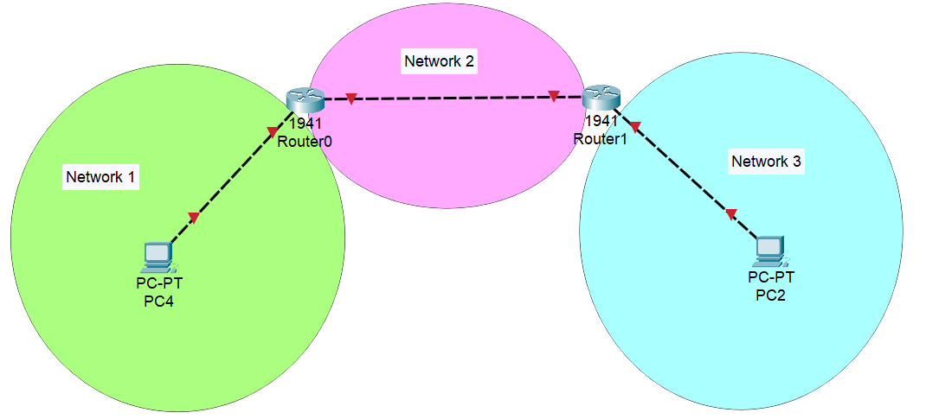Design a network as figure above with root IP 192.168.1.0/24. Design according to following:

1. Design Network 1 with 10 hosts (IP address) and assign router as first usable IP address and PC4 with last usable IP address.
2. Design Network 3 with 4 hosts and assign router as second usable IP address and PC2 as first usable IP address.
3. Design Network 2 with 2 hosts and for left router use first usable IP address and for right router use second usable IP address.

*Note: Use VLSM for network planning.*